**Group Catering**

Make your group visit extra special and relaxing by pre-ordering your catering and eat together in a private dining area at a time convenient to you.

Please choose one option for your whole group from the menu below, making one payment for the whole group no later than 14 days in advance of your visit. This will be taken as your final numbers and is non-refundable should numbers decrease. If you wish to order additional catering after your payment please contact us no later than 48 hours before your visit and we will do our very best to accommodate you.

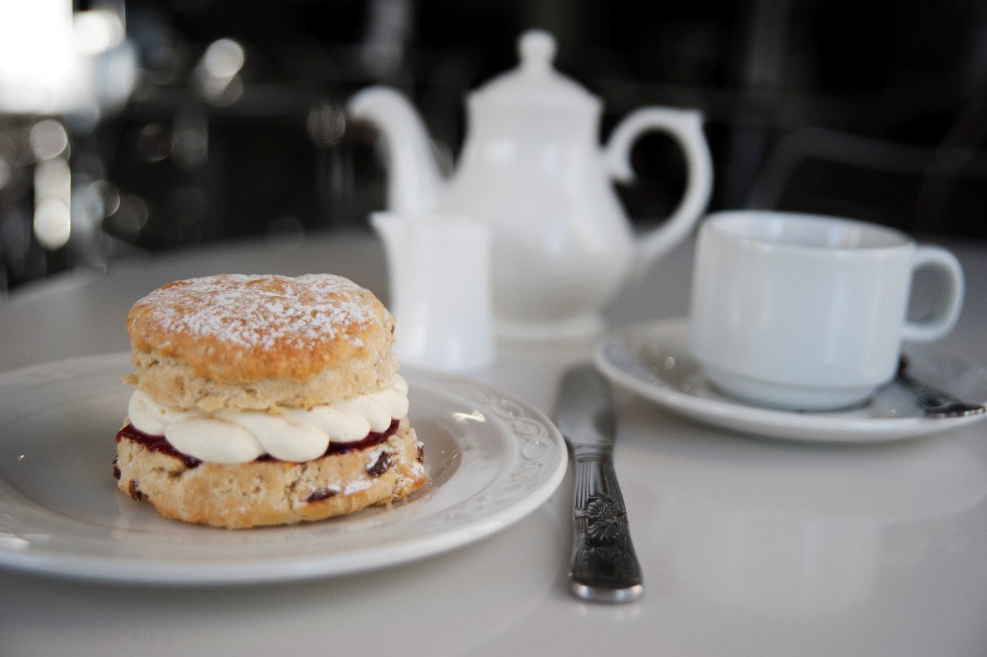

**Light Menu**

(G, D, E)

**Tea or Coffee**

Served with Homemade Shortbread

£4.50 per person

(G, E, D, S)

**Homemade Fruit Scone**

Served with Jam, Fresh Cream and Tea or Coffee

*£7.50 per person*

(D, E, F, G, Mt, N, S, Sb)

**Sandwich and Cake Selection**

Served with Tea or Coffee

*£12.50 per person*

*Add Soup for £2.50 per person*

(D, E, F, G, Mt, N, S, Sb)

***Soup and Sandwich Selection***

Served with Tea or Coffee

*£12.50 per person*

*Add Cake for £2.50 per person*

(D, E, F, G, Mt, N, S, Sb)

**Afternoon Tea**

Ham, Cheese, Salmon & Cucumber Finger Sandwiches, Homemade Mini Scones with Tiptree Preserves & Cream, ‘Swan Shortbread’ & Selection of Homemade Sweet Treats, served with Tea or Coffee.

*£18.50 per person*

*Quarter Bottles of Prosecco are available for an additional £8 per person*

**Lunch Menus**

|  |  |
| --- | --- |
| **The Swan Two Course**  *£20.95 per person*  (D, E, F, G, Mt, N, S, Sb)  **Roast Breast of Chicken**  Lemon & Thyme Stuffing, Creamed Savoy Cabbage, Rosemary Roasted Potatoes, Rich Roast Gravy  (Ve, Sb)  **Aubergine & Vegetable Lasagne**  Creamed Savoy Cabbage, Rosemary Roasted Potatoes  (G, D, E)  **Chocolate Tart**  Thick Cream, Black & Cherry Compote  Served with Tea & Coffee | **The Bowes Buffet**  *£22.95 per person*  (G, D, E,)  Cold Roast Ham  Seasonal Vegetable Quiche  Mozzarella, Tomato & Basil Salad  (G, D, E,)  Coleslaw  Salad Leaves  Selection of Breads  (D, E,)  Chocolate Brownie  Vanilla Meringue  Served with Thick Cream & Fruit Compote  Served with Tea & Coffee |
|  |  |