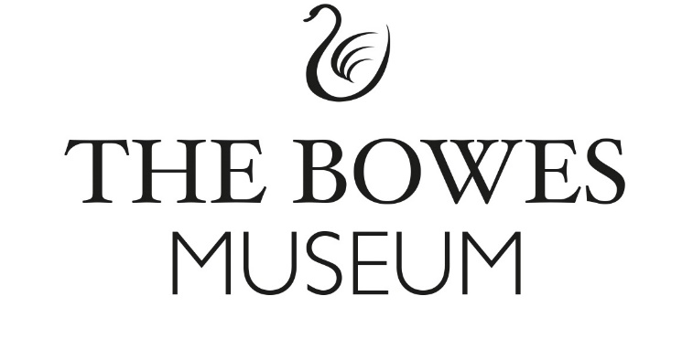

**Appendix 1: Additional information**

*Please complete this form and return, along with your main Proposal Document.*

**Section A: Details**

A1: Consultant/Company Name: Click or tap here to enter text.

A2: If answer to A1 is a Company Name, please provide the name and position of the main contact applying on behalf of the company: Click or tap here to enter text.

A3: Telephone number and email address: Click or tap here to enter text.

A4: Registered Office (if applicable): Click or tap here to enter text.

A5: Registration Number (if applicable): Click or tap here to enter text.

A6: Please detail brief CVs of the key personnel that will be delivering this contract: If you provide information in a separate document, please indicate this.

Click or tap here to enter text.

**Section B: References**

B1: Please provide two relevant client references. If you provide information in a separate document, please indicate this.

Click or tap here to enter text.

**Section C: Statements**

**C1: Health and Safety -The Bowes Museum requires that organisations confirm the following:**

* To provide adequate control of health, safety and welfare risks arising from the organisation’s work activities, which may affect the Bowes Museum’s workforce or others.
* To consult with The Bowes Museum’s workforce on matters affecting Health and Safety.
* To provide and maintain safe plant and equipment at all times.
* To ensure all members of the organisation’s workforce are competent in their roles, with an adequate level of training, information, instruction and supervision to be able to fulfil the roles.
* To minimise and so far as possible prevent accidents and cases of work-related absence and ill health.
* To maintain safe and healthy working conditions.
* Ensure that your workforce will keep to all relevant Health and Safety legislation.
* Comply with any instructions from The Bowes Museum’s supervising or Safety Officers.

Agreed and signed for on behalf of your organisation by:

Name: Click or tap here to enter text.

Position within the organisation: Click or tap here to enter text.

Organisation’s name: Click or tap here to enter text.

Date: Click or tap here to enter text.

**C2: Equality and Diversity Statement -The Bowes Museum requires that organisations confirm the following:**

* Compliance with statutory obligations under the Equality Act 2010.
* Commitment to non-discrimination and the advance of equality in your business processes.
* Commitment to fostering good relations based on ethical practices when running your business and providing services.
* That there has been no finding of unlawful discrimination against the Organisation in the last five years.

Agreed and signed for on behalf of your organisation by:

Name: Click or tap here to enter text.

Position within the organisation: Click or tap here to enter text.

Organisation’s name: Click or tap here to enter text.

Date: Click or tap here to enter text.

**Section D: Insurance** - Please provide details of Public Liability and Professional insurance cover held by your organisation:

D1: Insurer: Click or tap here to enter text.

D2: Policy number: Click or tap here to enter text.

D3: Value of cover: Click or tap here to enter text.

D4: Expiry date: Click or tap here to enter text.