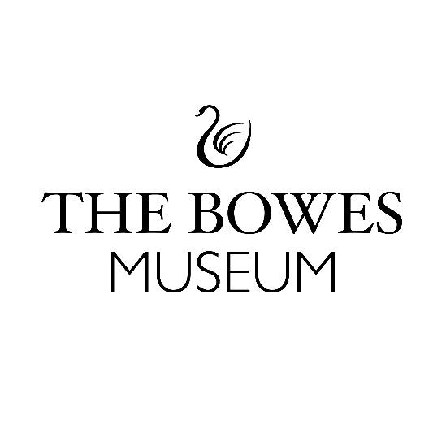

Swan Explainers Volunteer Information Sheet:

Background Information:
This year, we’re bringing back the magic of the Silver Swan. And we need your help!
We’ve been awarded funding from the National Lottery Heritage Fund to start significant conservation work on our Silver Swan. This restoration project of the Museum’s 18th century life-size swan automaton will enable the Swan to perform again sustainably…and just in time for a festive celebration!
The Silver Swan contains 2,000 moving parts and three clockwork mechanisms and was the most expensive purchase in our founders, Josephine and John Bowes’ original Museum collection. We need your help to share the restoration project with our visitors, to collect memories from our audiences about their Silver Swan-encounters and to help articulate the conservation process (with support from our trained team of conservators and horologists) through welcoming conversation, creating an inclusive space and supporting engaging activities.
The Role:
- To welcome visitors into the Swan exhibition space and provide information about the Swan, especially as it may sometimes be off-site, for important conservation work to take place.

- Be confident and comfortable talking with lots of different people, capturing their thoughts and memories about the Silver Swan and perhaps the first time they experienced its magic.

- Enjoy creating a welcoming, inclusive and engaging space for all visitors by providing information about the Silver Swan, as well as engaging in conversations and inviting people to take part in related activities.
Time Commitment:
- We are looking for volunteers who can do at least 1 x shift per week from October to December 2023.

- Shifts will be split between a morning and afternoon shift of 3 hours - 10.30am – 1.30pm and 1.30pm – 4.30pm.
Key Dates for your Diary:
- Deadline to apply is Sunday 24th September 2023 at midnight.

- Be available to attend an informal interview on 3rd or 4th October at The Bowes Museum.

- Be available to attend Induction training on Wednesday 11th Oct at The Bowes Museum.

- Be available to begin volunteering week beginning 18th October 2023 – end of December 2023.

- Be available to attend an exit evaluation feedback session in January 2024.

How to apply:
- You must be over 18 years to apply for this volunteering opportunity.

- Download your application form from the Museum website https://thebowesmuseum.org.uk/jobs-and-volunteering – and email the completed application form by 24 September 23:59 and send to Jess White, Co-production Volunteer Manager jess.white@thebowesmuseum.org.uk

- If you cannot access the internet, you can collect a printed version of the application form from Reception desk at The Bowes Museum. Please return your completed application form in a sealed envelope marked Private and Confidential for the attention of Jess White – Co-production Volunteer Manager by Sunday 24th September 2023.

Benefits of Volunteers with The Bowes Museum:
- Learn about the Silver Swan from Curators at The Bowes Museum.

- Gain new social networks.

- Attend specialist induction training.

- Receive 15% discount at The Bowes Museum Shop and Café after one month’s volunteering service.

- After the conservation work is completed attend a celebration event of the Silver Swan.

If you have any questions about this volunteering opportunity, please feel free to get in touch directly with Jess White – Co-production Volunteer Manager by email: jess.white@thebowesmuseum.org.uk

The Bowes Museum is a Registered Charity | Charity Number – 1079639

