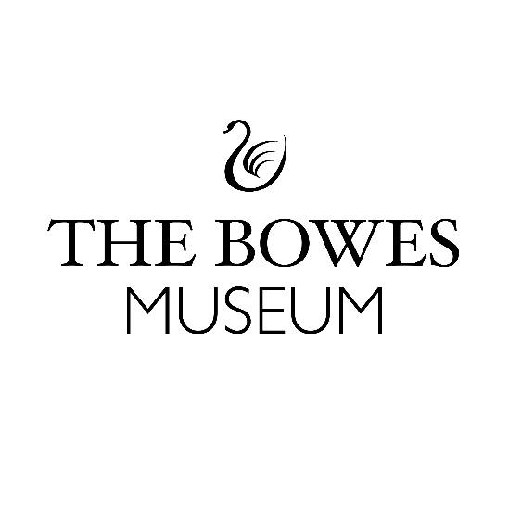

Curiosity Activator Volunteer Information Sheet
Background Information to the Curiosity Project:
This year we are launching four new exciting gallery spaces and accessible storage vaults through the Curiosity Project, and we are looking for volunteers to help us activate these new spaces!
The Curiosity Project will see the galleries on the ground floor of the Museum transformed into interactive spaces that will celebrate the collection, inspire curiosity and encourage exploration and conversation. Our visitors told us they wanted to explore the stories behind our objects, have making experiences that help them get hands-on with materials and techniques and learn more about the Artists, Designers and Makers whose works are cared for by the Museum. Our new spaces will do all of this!
Three former offices and educational spaces in the Museum’s vaults have also been stripped back ready for the rooms to be kitted out with new display systems to better store and care for our collection. Stored furniture, textile and ceramic objects will also be accessible to visitors in specialist guided tours from April.
The galleries on the ground floor have been cleared, shutters to long-closed windows reopened and new flooring laid. They’re being transformed into:
A Curiosity Space, where a soundscape linking the gallery to the outside will change as visitors move around the room investigating objects and artworks. Our displays will change regularly but in April we’ll introduce Artists, Designers and Makers, ideas about neighbourliness and hospitality and the Teesdale landscape, all through items from the collection.
A Create Space to investigate the making processes of collection objects; experimenting with materials through prompts and ideas set by our Artist team.
Additionally, one of our first floor rooms, which until recently was used for storage, will become an area known as the Hive. This will be a ‘hive of activity inspired by our co-founder, Josephine Bowes’ thoughtful collecting. Here, visitors will be able to see objects, artefacts, documents and collections that have been curated through a collaboration of staff, volunteers and community members; a reminder that everyone can collect and everyone curates.
Curiosity Activator – The Role:
- To create a welcoming environment for visitors to explore our four new gallery spaces as part of the Curiosity Project. (The four new spaces are: Create, Conversation and Curiosity which are all on the ground floor as well as the Hive which is on the first floor).

- Be confident and comfortable talking with all audiences including families, young people and adults.

- Be happy getting hands-on with making and creating prompts and helping visitors to explore these different spaces and activate them.

- Enjoy creating a welcoming, inclusive and engaging space for all by providing information about the Curiosity Project, as well as engaging in conversations and inviting people to take part in related activities that may be taking place in different spaces.

Time Commitment:
- We are looking for volunteers who can do at least 2 x shifts per week from April to September 2024. (Or a full day which is 10am – 16.30pm, with half an hour break for lunch).

- Shifts will be split between a morning and afternoon shift of 3 hours - 10.00am – 1.00pm and 1.00pm – 4.00pm.

- This is a trial period, and we will review the Curiosity Activator Role after an initial six-month period, with the intention to continue having volunteers after September 2024.
Key Dates for your Diary:
- Deadline to apply for this volunteer role is Sunday 17th March midnight.

- Be available to have an informal chat on either Weds 20th or Thurs 21st March at The Bowes Museum.

- Be available to attend Induction training on either Tues 26th or Weds 27th March at The Bowes Museum.

- Be available to volunteer on the launch date Tues 2nd April 2024.

- Be available to begin volunteering week beginning 1st April – end of September 2024.

- Be available to attend a feedback and evaluation session in October 2024.
How to apply:

- Download your application form from the Museum website: https://thebowesmuseum.org.uk/jobs-and-volunteering/ – and email the completed application form to Jess White Co-production Volunteer Manager jess.white@thebowesmuseum.org.uk

- If you cannot access the internet, you can collect a printed version of the application form from Reception desk at The Bowes Museum from Monday 4th March 2024. Please return your completed application form in a sealed envelope marked Private and Confidential for the attention of Jess White – Co-production Volunteer Manager by Sunday 17th March 2024.
Benefits of Volunteering at The Bowes Museum
- Become part of our community of Volunteers at The Museum, make new friends and gain new networks in the Museum and Culture sector.
- Develop & gain new skills.
- Receive 20% discount at The Bowes Museum Shop and 20% discount at the Café in accordance with our Volunteer Discount Policy.
- Invites to special Volunteer Celebration Events at The Museum.

If you have any questions about this volunteering opportunity, please feel free to get in touch directly with
Jess White – Co-production Volunteer Manager by email: jess.white@thebowesmuseum.org.uk

The Bowes Museum is a Registered Charity | Charity Number – 1079639

