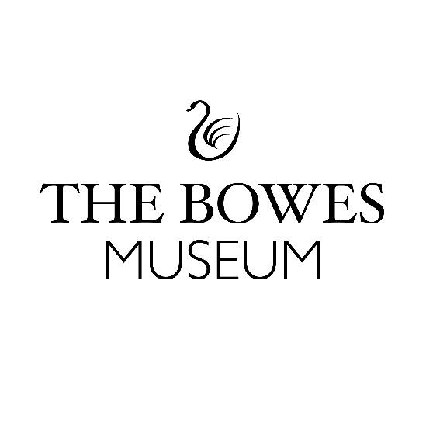

Expression of Interest Volunteer Form
We are delighted that you are interested in becoming a volunteer at The Bowes Museum, thank you for taking the time to complete this form, so we can learn a little bit more about you!
About You:
How would a best friend or close family member describe you in just three words?

What are your top 5 favourite things to do in your free time?

In 3 bullet points, please describe why you want to become a volunteer at The Bowes Museum?

What do you feel are your top 5 skills or traits that you can bring to the Museum as a volunteer?

In just 3 words, what are you hoping to gain from volunteering at the Museum?

Your Contact Details:
Name:
Email:
Contact number:

Are you happy to be contacted by Jess White – Co-production Volunteer Manager to have an informal chat regarding your volunteering interests at The Bowes Museum? Yes/ No
Please return your completed form by email to: volunteers@thebowesmuseum.org.uk
Alternatively, you can return your completed form to the Reception desk at the Museum, during opening hours (10.00-5.00) in a sealed envelope marked private and confidential for the attention of Jess White - Co-production Volunteer Manager, The Bowes Museum, Barnard Castle, DL12 8NP.

The Bowes Museum is a Registered Charity | Charity Number – 1079639

