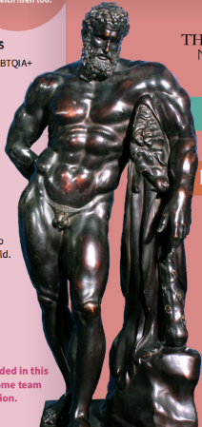**Bronze Hercules, 1850**

**Maker Unknown**

**Bronze**

**M.243**

In Ancient Greece, gender, sexuality, and relationships were often understood in ways that challenge contemporary binary perspectives. Herakles (or Hercules in Roman mythology) has long been celebrated as the ultimate symbol of masculinity. Yet, his story is far more complex than modern interpretations suggest.

Alongside his many female lovers and wives, Heracles had numerous male companions with whom he was deeply intimate with. Hylas, for example, joined Heracles on his journey with Jason and the Argonauts in search of the Golden Fleece. Lolaus, his charioteer, played a crucial role in the battle against the Hydra, searing its wounds after Herakles severed its heads. Their bond was so celebrated that Lolaus' tomb in Thebes became a site where male couples would exchange vows, pledging their devotion to one another in the Greco-Roman time.

For the Ancient Greeks, sexuality as fixed identity did not exist, and it is hard for us to comprehend that there was no such word that specifically meant same sex love. Instead, sexual relationships were structured around power dynamics—dominance and submission—rather than gender or preference. High-status men engaged in relationships with adolescent youths of the same class, as women were largely excluded from intellectual and social spheres. A boy was not considered a man until he could grow a full beard. Until then, he occupied the role of an **eromenos** (beloved), guided and mentored by an **erastes** (lover), an older man responsible for his education, protection, and preparation for adulthood.

These relationships were seen as essential to a young man’s development, shaping him into a future citizen, warrior, and leader. Through them, knowledge, status, and power were passed down. While modern interpretations may impose rigid ideas of sexuality and masculinity onto these myths, the reality of Ancient Greek relationships reveals a world of fluidity, mentorship, and connection that resists simple classification as we know it now.

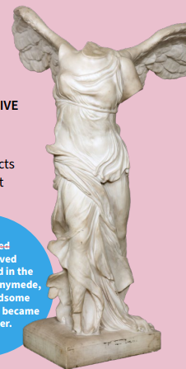**The Winged Victory of Samothrace, 1863**

**Maker Unknown**

**Marble**

**B.M S.125**

The Winged Victory of Samothrace, also known as the Nike of Samothrace was discovered in April 1863 on the island of Samothrace by the French consul and amateur archaeologist Charles Champoiseau. The original statue is thought to have been created between 100 and 300 BC to honour Nike, goddess of victory and messenger of Zeus and Athena. It is considered to be one of the finest examples of Hellenistic period sculptures.

The goddess is depicted descending from the skies, the supple body and wide, extended wings vibrate with the movement of flight. The statue was sent to Paris in 1863, and since 1884 has dominated the Daru staircase in the Louvre, while a plaster replica stands in the museum at the original location of the Sanctuary of the Great Gods on Samothrace.

It is a masterpiece of Hellenistic art, embodies movement, triumph, and divine favour. As the winged personification of victory, Nike’s presence signified success in battle and competition. She was not only Zeus’s devoted ally but also played a role in one of mythology’s most famous homoerotic tales—the abduction of Ganymede.

In Greek myth, Ganymede, a mortal of unparalleled beauty, was taken to Olympus to become Zeus’s cupbearer—and, in later retellings, his lover. Nike, swift and unwavering, aided in his ascent, linking her image of victory to the divine sanctioning of queer love. Through her, triumph was not just military but personal, extending to those chosen by the gods for glory, favour, and affection.

Nike, as the embodiment of victory, represents more than just military success—she signifies triumph over all struggles, including deeply personal battles. In mythology, any association with Nike meant that a person or god was destined to win, reinforcing the idea that perseverance and resilience lead to triumph. For the queer community, this symbolism is powerful: the fight for identity, acceptance, and love is a battle in itself, and Nike’s presence affirms that victory is inevitable for those who stand firm in their truth.

Nike’s role in the myth of Ganymede, a story that evolved into one of divine queer love, further strengthens this connection. Just as Nike uplifted gods and mortals alike, her legacy can embolden LGBTQ+ individuals to embrace their journey with the confidence that they, too, are worthy of triumph. Victory, as Nike teaches, is not just about conquest—it is about claiming one’s rightful place in the world, unapologetically and with pride.

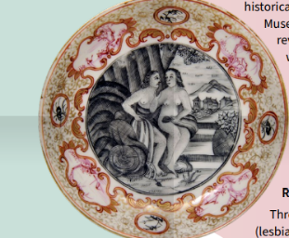

**Cup and Saucer, c. 1730,**

**Jingdezhen Porcelain**

**Glazed porcelain**

**X.5631**

This cup and saucer, is an entry point into a larger conversation about gender representation, ambiguity, and the assumptions we bring to objects in museum collections. Museum records catalogue this couple as heterosexual, but as we continually reassess our collection, and would like to ask what gender do you see?

This cup and saucer, produced in 18th-century Jingdezhen, invites us to reconsider how gender is represented, both in this object and across museum collections. While porcelain has often been associated with femininity—its delicacy, smoothness, and refinement paralleling cultural ideals of the female body—its history reveals more fluid and layered meanings. The act of drinking tea, for example, was a highly ritualised practice across cultures, performed by people of all genders, and yet shaped by shifting social expectations.

Chinese ceramics, including those exported to Europe, frequently depicted figures that do not conform to rigid gender binaries. Painted scenes on porcelain often blend characteristics that might be read as masculine or feminine, reflecting broader artistic traditions in which androgyny was idealised or where gender presentation was ambiguous. Such representations challenge the assumption that gender is fixed, instead revealing a more nuanced and fluid understanding of identity across time and place.

Museums have long categorised objects and their histories through binary gender frameworks. Yet collections contain a multitude of representations that defy these structures—figures with ambiguous dress, gestures, and facial features; depictions of historical roles that blurred gender boundaries; and objects, like the figures on this porcelain, that complicate the ways gender has been assigned to material culture. By re-examining these pieces, we uncover narratives of gender nonconformity and fluidity that have always existed, even if they have been overlooked or misinterpreted.