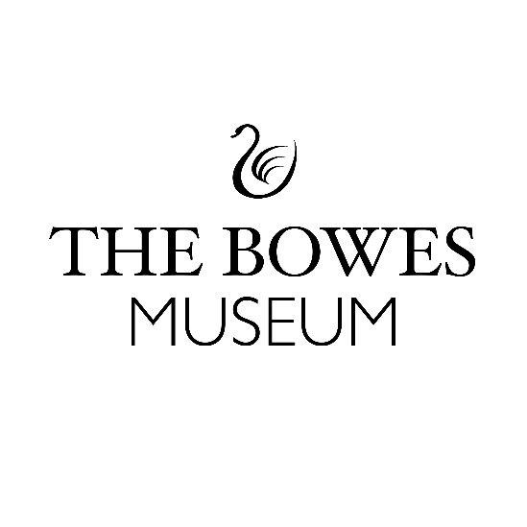
THE FOUNDERS’ GALLERIES: GALLERY STORYTELLER VOLUNTEER
Application Form (Confidential)
Thank you for your interest in applying to become a Gallery Storyteller with The Bowes Museum. We are so excited to be reimagining the Founders Galleries and are thrilled and delighted that you want to become part of it!
Background information to The Founders’ Galleries-
The Founders’ Galleries are three newly developed spaces at The Bowes Museum that retell the remarkable story of our founders, Joséphine and John Bowes. This exciting project was co-produced with Weardale Together and UTASS (Upper Teesdale Agricultural Support Service), embedding the voices and perspectives of our local rural communities into the heart of the museum.
Founded by Joséphine & John Bowes 150+ years ago, as a gift to the people living in the local communities of Teesside and County Durham, this purpose-built museum brings together an extraordinary, designated collection of European ﬁne and decorative art as a cultural resource for the people of Northern England. Today, we celebrate artists, designers and makers.
For more information about The Founders’ Galleries: Gallery Storyteller role, please read through the information sheet titled: Volunteer Role: Founders’ Galleries Gallery Storyteller
Inclusion and Diversity-
We believe that diversity and equality within our workforce, programmes and approaches is crucial to our mission of being inclusive and relevant to our communities. We want everyone to feel welcome. We, therefore, particularly welcome applications from candidates under-represented at The Bowes Museum and within the heritage sector, including Global Majority candidates and/or candidates with disabilities.
Please note before applying for this volunteer role that you will be available to attend on the below dates:
- Be available to come in for an informal conversation about the role on Wednesday 28th January 2026.

- That you will be available to attend a Training Day on Friday 13th February 2026.

If you are keen to take part in this role, but are unable to commit to any of the dates above, please get in touch and we can discuss.

Your Personal Details
IMPORTANT: If you are under the age of 18 you must ask your parent or guardian to complete this section on your behalf.
Full Name

Address

Postcode

Telephone number

Mobile number

Contact number of Parent or Guardian

Email

I am over 18. | Yes No
I am legally entitled to volunteer in the UK | Yes No

Why would you like to become a Gallery Storyteller Volunteer?
(Maximum of 100 words, feel free to write in bullet-points if you prefer).

What skills, experience and knowledge are you hoping to gain by volunteering at The Bowes Museum?
(Maximum of 100 words, feel free to write in bullet-points if you prefer).

Availability
Please tick when you are available to volunteer.  (Ideally, we are looking for people to be able to do 1 or more shifts a week) |  |  |  |  |  |  |  | Additional Comments
 | Mon | Tues | Weds | Thurs | Fri | Sat | Sun | We also welcome volunteers who would like to do a whole day shift.  (10.30 – 3.30pm with 30-minute lunch break).
10.30am
to 1.30pm
1.30pm to 3.30pm

Reference:
Please provide details of one person who can tell us about your ability to undertake volunteering at The Bowes Museum. (Must be someone you have known longer than 6 months and not be a relative or friend)
This role is subject to a satisfactory reference check, in supplying this reference you give us permission to contact your reference.
Reference contact details:

Name:

Email:

Telephone:

How do you know this person?

Privacy Policy
The Bowes Museum is committed to protecting and respecting your privacy. We are responsible for protecting your information as a “data controller’’ under the applicable data protection legislation. For more information log on to our website at:
https://thebowesmuseum.org.uk/privacy-policy/ Your records will be held on the museum’s database and will not be passed to any third party without your agreement.

Declaration
I declare that the information I have given in this application is, to the best of my knowledge and belief, true and correct. I agree to the information on this form being stored by The Bowes Museum under our privacy policy.

Parent or Guardian signature:
Date:

Your Signature:
Date:

If you would like any support completing your application form, please feel free to contact
Nina Kingham– Co-production Volunteer Manager – nina.kingham@thebowesmuseum.org.uk
(Please note I work part time).
If you require this application form in a larger format, please do not hesitate to contact me by email harriet.rosie@thebowesmuseum.org.uk

Please return your completed application form to The Bowes Museum by no later than Monday 12th January 2026.
- Email: Harriet Rosie, Producer (Young People & Adults) harriet.rosie@thebowesmuseum.org.uk

- Or drop it off in a sealed enveloped marked Private and Confidential for the attention of Harriet Rosie, Producer (Young People & Adults) to our Reception desk during opening hours: The Bowes Museum, Barnard Castle, County Durham, DL12 8NP.

Thank you for taking the time to complete this application form
The Bowes Museum is a Registered Charity | Charity Number – 1079639

