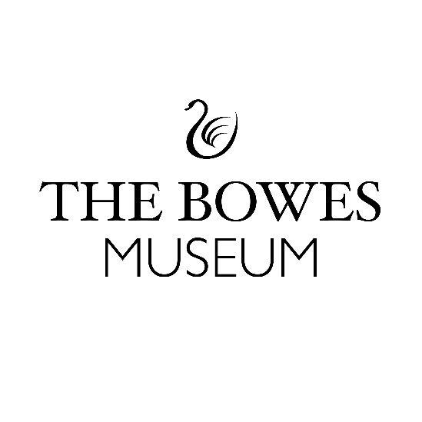
Work Experience Expression of Interest Form
Thank you for your interest in undertaking a work experience placement at The Bowes Museum. We are delighted you have chosen to look at The Bowes. We receive a high number of requests every year for work experience placements and sadly, we cannot accommodate them all, but we will consider each application and try to help where we can. We can only accommodate a limited number of placements each year. Applications for school placements in the summer of any given year need to be with us by the end of February that same year for consideration. and the deadline for the next academic year is end of February 2026, for a placement in early July 2026.
We are looking for people who are hungry for the opportunity and will maximise their learning through this experience at the Museum. We want people who are genuinely interested in careers in the Museum sector and who want to contribute to the Museum after their placement ends.
If this sounds like you, then we’d love to hear from you.
About You:
We want to learn all about you, what your passions and interests are, what you love doing.
So tell us what you love to do, what your passions and interests are:
(Maximum of 100 words/ fine to use bullet points if you prefer)

Why The Bowes Museum?
We want to know why do you want to do your work experience at the museum?
Please tell us why you specifically want to do your work experience at The Bowes Museum?
(Maximum of 100 words, and it fine to use bullet points if you prefer)
What do you want to get from your work experience?
We want to know what you are hoping to gain from your work experience placement?
What skills or experiences do you want to gain?
(Maximum of 100 words, and it fine to use bullet points if you prefer)

What can you contribute to The Bowes Museum?
What can you bring to the Museum?
What skills, knowledge or experiences can you bring to the Museum?
(Maximum of 100 words, and it fine to use bullet points if you prefer)

How will you share your learning experience after your placement ends?
We want you to share your work experience journey more widely, to help you reflect on your experience and time with us and share your story with other people interested in doing work experience at The Bowes Museum.
How might you share your learning experience?
(Maximum of 100 words, and it fine to use bullet points if you prefer)

Your Contact Details:
Your name

Your age

Parent or guardian name

School/ College address

Contact email

Parent or Guardian signature if you are under the age of 18 years old:
Date:
Your Signature:
Date:

If you would like any support completing this form, please feel free to contact:
Nina Kingham – Co-production Volunteer Manager – nina.kingham@thebowesmuseum.org.uk
(Please note I work part time and flexibly)
If you require this application form in a larger format, please do not hesitate to email nina.kingham@thebowesmuseum.org.uk
Please return your completed work experience expression of interest form to The Bowes Museum before end of February 2026, for a July 2026 week-long placement.
- Email: Nina Kingham, Co-production Volunteer Manager nina.kingham@thebowesmuseum.org.uk

- Alternatively, drop off your form in a sealed enveloped marked Private and Confidential for the attention of Nina Kingham, Co-production Volunteer Manager at our Reception desk during opening hours (10.00-5:00): The Bowes Museum, Barnard Castle, County Durham, DL12 8NP.

Thank you for taking the time to complete this expression of interest form.
The Bowes Museum is a Registered Charity | Charity Number – 1079639

