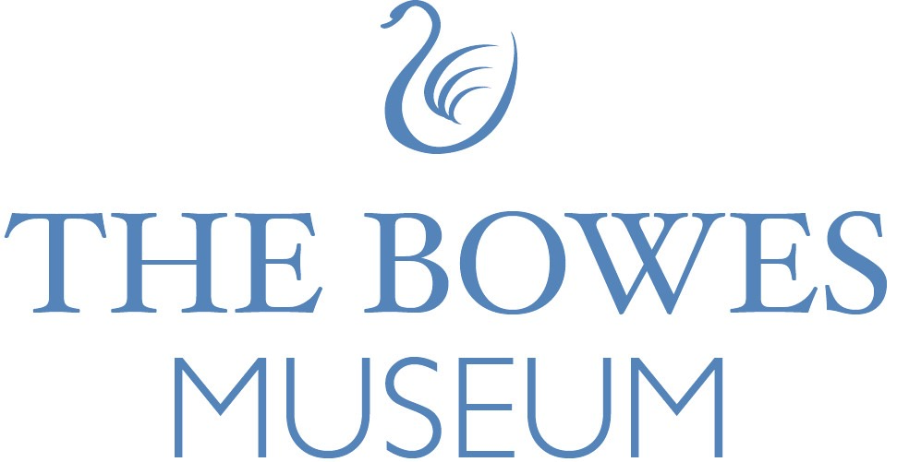

Tender for Funding & Investment Development Partner, Towards Bowes 2092

Issue Date: 11/03/2026

Return Date: 01/04/2026

Overview: to engage an individual or organisational partner who will work with us to develop and enhance our Funding and Investment Model, to:
- Maximise investment income.
- Stabilise our core funding.
- Identify strategies and opportunities for new funding and income, including philanthropy.
- Realise the potential of our cultural and physical assets.
- Explore efficiencies in our working processes.

Section A: Details
A1: Consultant/Company Name: Click or tap here to enter text.
A2: If the answer to A1 is a Company Name, please provide the name and position of the main contact applying on behalf of the company. Click or tap here to enter text.
A3: Telephone number and email address: Click or tap here to enter text.
A4: Registered Office (if applicable): Click or tap here to enter text.
A5: Registration Number (if applicable): Click or tap here to enter text.
Section B: Experience and Approach
B1: Please provide a brief history of your professional or company evolution:
Click or tap here to enter text.
B2: Please detail brief CVs of the key personnel that will be delivering this contract:
Click or tap here to enter text.

B3: Regarding the requirements detailed in sections 4-8 please provide the following details and evidence to support your bid for this contract:
- B3.1 Details of your experience related to this project, including evidence of previous work and delivering similar or relevant commissions within the past 5 years (minimum of 3 examples). Details should include client details, project title and description of the service you provided.

- B3.2 A detailed response on how you will approach and fulfil the brief’s requirements, including a project plan outlining your approach and methodology, timings, and associated resource allocations. Your project plan should include:
  - How the project will be approached.
  - A detailed project plan including the responsibilities of team members through the different stages of the project and a timetable showing key milestones, dates, and resource allocations.
  - Key issues that may impact the delivery of the work and how you anticipate managing these within the project.

- B3.3 Confirmation of capacity to complete the work within the indicated timeframe and the following information:
  - Details of the Project Team members and CVs of the lead staff and their specific responsibilities and any arrangements for subcontracting parts of the work.

- B3.4 Price – Provide professional fees and associated costs for this project's Design and Project Management.
If you provide information in a separate document, please indicate this.
Click or tap here to enter text.

Section C: References
C1: Please provide two relevant client references from projects within the past five years:
Click or tap here to enter text.

Section D: Statements
D1: The Bowes Museum requires organisations/ consultants to make the following commitments to Health and Safety by signing the undertaking:
- To provide adequate control of health, safety and welfare risks arising from the organisation’s work activities, which may affect the Bowes Museum’s workforce or others.
- To consult with The Bowes Museum’s workforce on Health and Safety matters.
- To provide and maintain safe plant and equipment at all times.
- To ensure all members of the organisation’s workforce are competent in their roles, with an adequate level of training, information, instruction and supervision to be able to fulfil the roles.
- To minimise and, so far as possible, prevent accidents and cases of work-related absence and ill health.
- To maintain safe and healthy working conditions.

You agree to:
- Ensure that your workforce will keep to all relevant Health and Safety legislation.
- Comply with any instructions from The Bowes Museum’s supervising or Safety Officers.

Agreed and signed for on behalf of your organisation by:
Name: Click or tap here to enter text.
Position within the organisation: Click or tap here to enter text.
Organisation’s name: Click or tap here to enter text.
Date: Click or tap here to enter text.
D2: Equality and Diversity Statement
The Bowes Museum requires that organisations confirm the following:
  - Compliance with statutory obligations under the Equality Act 2010.
  - Commitment to non-discrimination and the advance of equality in your business processes.
  - Commitment to fostering good relations based on ethical practices when running your business and providing services.
  - That there has been no finding of unlawful discrimination against the Organisation in the last five years.
Please confirm the above (should be signed by partner or director, on behalf of the organisation:
Name: Click or tap here to enter text.
Position within the organisation: Click or tap here to enter text.
Organisation’s name: Click or tap here to enter text.
Date: Click or tap here to enter text.
D3: Insurance
Please provide details of Public Liability and Professional insurance cover held by your organisation:
Insurer: Click or tap here to enter text.
Policy number: Click or tap here to enter text.
Value of cover: Click or tap here to enter text.
Expiry date: Click or tap here to enter text.

Please email your proposal along with a completed Appendix 1, (or any questions before submitting) to: Lisa Bell lisa.bell@thebowesmuseum.org.uk

