
THE BOWES
MUSEUM

AN EXCITING OPPORTUNITY

APPOINTMENT OF
Travel Trade and Events Coordinator

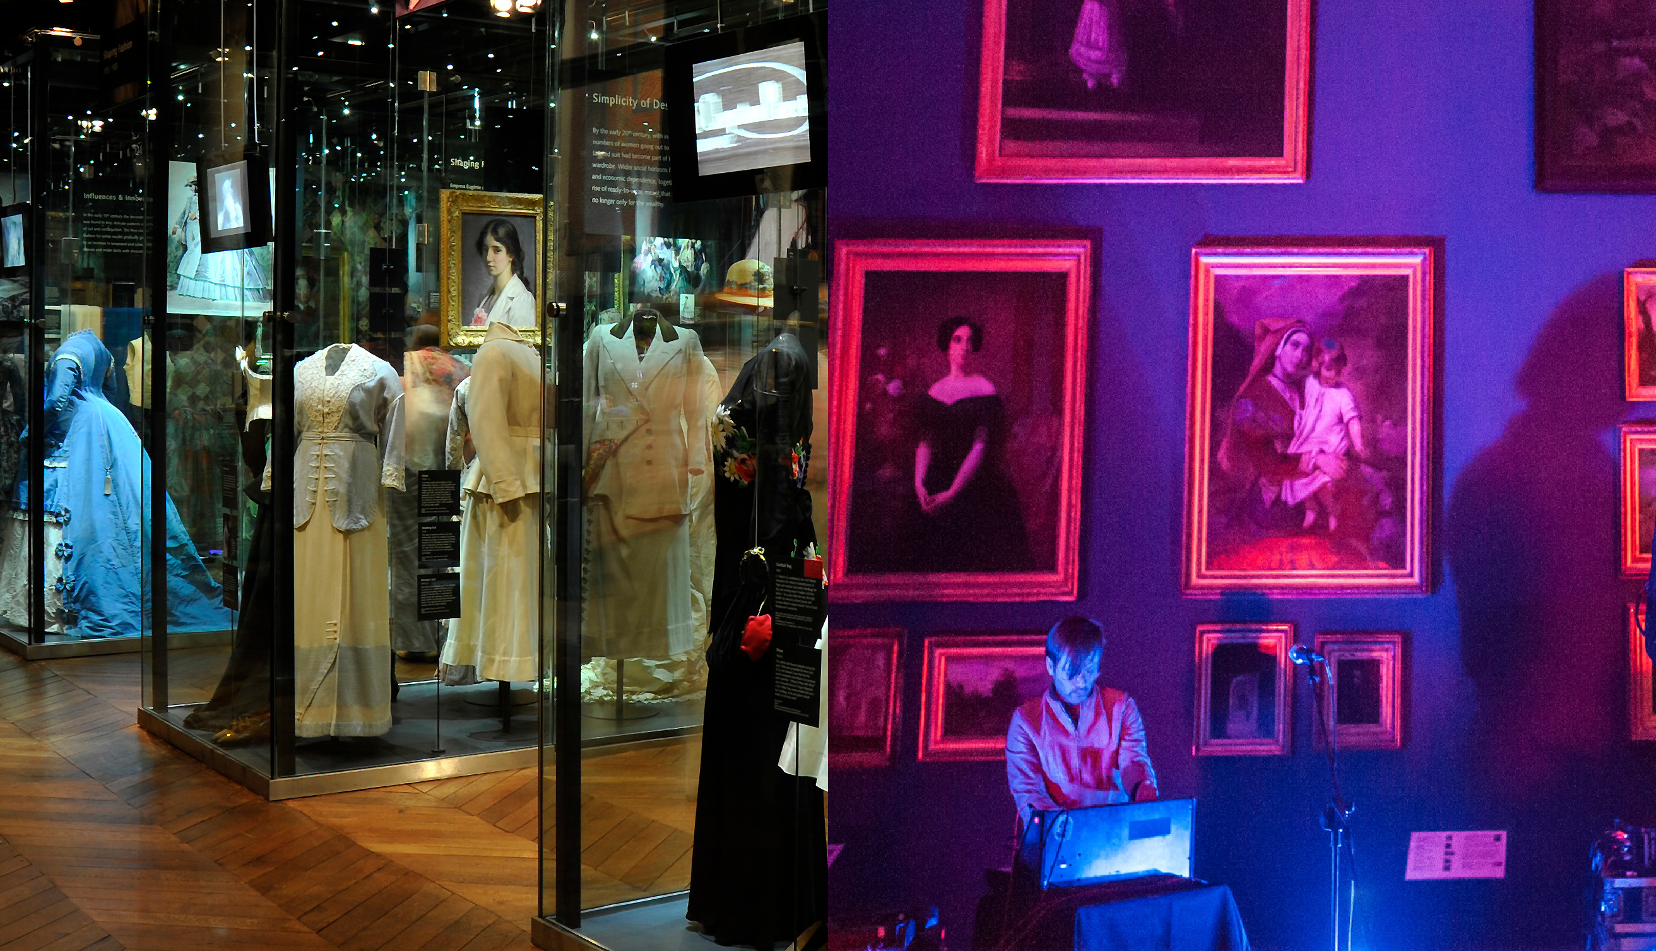

THE BOWES
MUSEUM
APPOINTMENT: TRAVEL TRADE AND EVENTS COORDINATOR 3


A future-thinking museum of artists, designers, and makers, created
to support and uplift people and places.
The story of The Bowes Museum is like no other: uniquely, the idea of a woman, Joséphine Bowes, an artist and patron of the arts.
Her determination and passion
for creating a museum were shared by her husband John, who was born in Teesdale.
The Museum stands proudly in the heart of Teesdale, an Area of Outstanding Natural Beauty.
Mission, vision, and values.
Our mission as a future-thinking museum of artists, designers, and makers is to support and uplift the North East through our spirit of generosity and collaboration.

Through this we aim to achieve our vision of unlocking people’s potential to shape a more interesting,
equitable and sustainable world.

Our values underpin our work. We aim to be adaptable, collaborative, creative, experimental, fun, responsible and welcoming.

Collection
We hold the spirit of our founders, Joséphine and John Bowes, within our collections. Joséphine’s interests are reflected in the collection, particularly her love of fine porcelain, fashion, and art. She was a recognised artist who acquired the work of her contemporaries during a vibrant cultural period in 1800s Paris. Our collecting policy, associated programming, and display reflect Joséphine’s interest in the present and the new, celebrating creativity, design, and artisanship.
Visitor Experience
We seek to welcome all, support and celebrate artists, cultivate creative exchange, deliver inspirational learning, and be a place that is used and loved by the people of Teesdale and visitors from further afield.

We aim to put people first by understanding their needs and motivations. We do this by knowing and speaking to our audiences and making our exhibitions and events accessible, inclusive, and relevant. We view our programming ‘in the round’ and want to extend
it beyond our building. Recognising that engagement is digital and physical, we aim to connect with people where they are. We support artists, makers and designers, current and aspiring, through our programmes, exhibitions and partnerships.

Learning is at the heart of The Bowes Museum. We work extensively with children, young people, educators
and older people to raise aspirations and support education for life. Our incredible volunteers are a vital community, working with us in mutually-beneficial ways to support people and places.

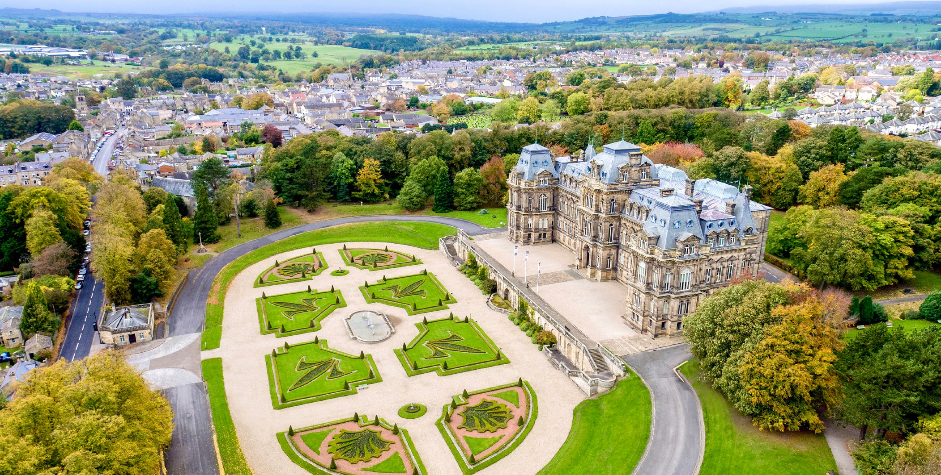
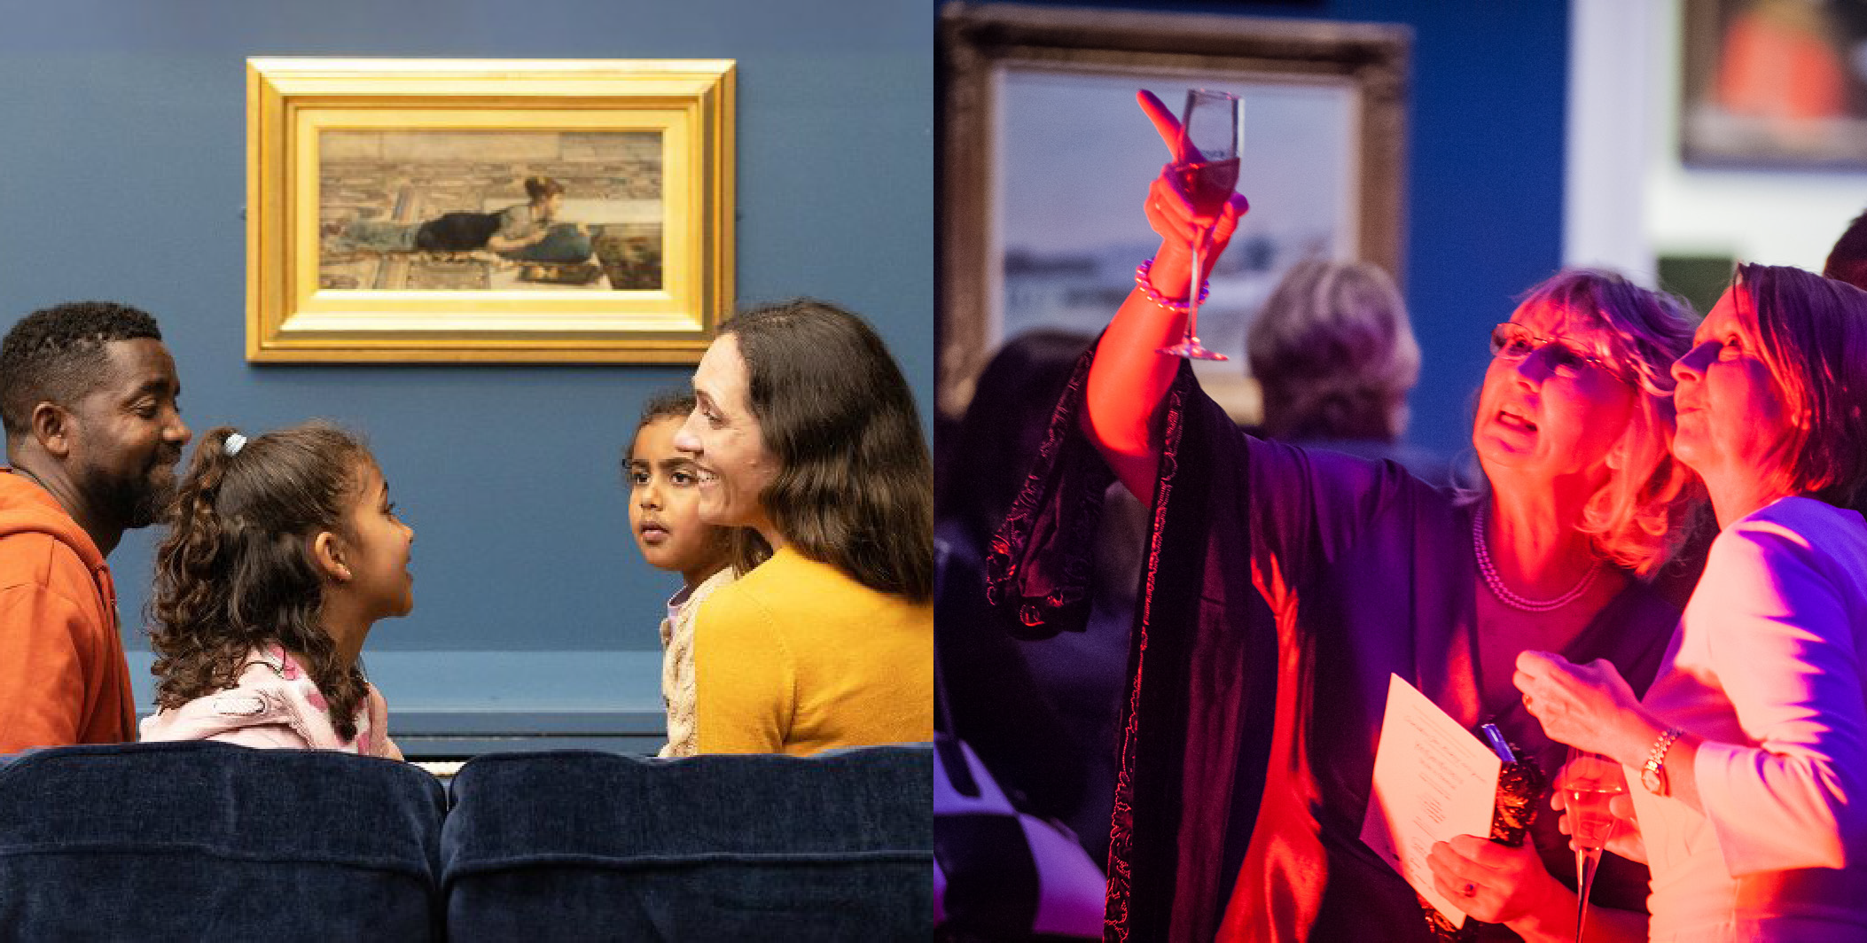
Our grounds are a welcoming space for everyone. We have over 20 acres for local people to call their own. They include a mixture of formal planting and woodland arboretum, with avenues of trees and a terrace, from which visitors can admire the spectacular views of the surrounding countryside. Our shop offers unique pieces inspired by our collections and exhibitions and features local artists and makers. As the Museum feeds the soul, our café feeds the body with its wonderful local and seasonal produce championing producers from Teesdale.

Trading and Operations
Today the Museum employs 80 staff and has a turnover of £3.3m in the charity and £945k in the the Enterprises Trading Company. Our team is responsible for a broad spectrum of work across operations, finances, exhibitions, programmes, commercial activities, marketing and collections. As an Arts Council England (ACE) National Portfolio Organisation (NPO), we are proudly contributing to ACE’s ‘Let’s Create’ mission.
Our audiences’ needs, voices and responses are vital to our success. We aim to ensure our audiences recognise and celebrate the Museum
and its collections as vital to them. There are many parallels between the time of our founders and issues affecting society today.

THE BOWES
MUSEUM
APPOINTMENT: TRAVEL TRADE AND EVENTS COORDINATOR 5

The Opportunity
We are seeking candidates for the position of :
Travel Trade & Events Coordinator.
Two-year fixed-term contract.
25 hours per week.

This role offers an exciting opportunity to help shape the direction of travel trade, groups and events for the long-term to ensure our relevance and impact in the years ahead is sustainable.
The opportunity includes
The opportunity to join The Bowes Museum as a Travel Trade & Events Coordinator, combining relationship-building, sales and event delivery in a visitor focused role.
You’ll lead the development of group visits by managing travel trade partnerships, handle enquiries from start to finish and drive bookings, while also supporting the planning and delivery of a diverse events programme.
The role offers a great balance of coordination and hands-on experience, from producing event plans and hosting group visits to representing the museum at industry events.
Ideal for a proactive, organised and people focused individual, it provides the chance to contribute to development through the museum’s growth strategy, build strong sector knowledge and play a visible role in enhancing the visitor experience. You’ll work across teams in a dynamic cultural environment, helping bring the museum to life for a wide range of audiences.

Role Purpose
The Travel Trade and Events Coordinator plays a key role within the museum’s Events Team, helping to deliver an exceptional customer journey for group visitors, event clients and travel trade partners. The post holder will lead on the travel trade operation promoting, driving and developing group visits to the museum while also supporting the planning, administration and delivery of the wider events programme across the museum.

You will be responsible for
- Managing group visit enquiries, processing bookings across multiple channels, and supporting events from planning through to delivery.
- Developing strong relationships with travel trade operators and partners This is a highly visible, visitor-facing role, requiring regular engagement with group visitors in the museum, sharing knowledge and stories that help bring The Bowes Museum to life.
- The role will also help manage wider visitor and client enquiries pertaining to events as required.

THE BOWES
MUSEUM
APPOINTMENT: TRAVEL TRADE AND EVENTS COORDINATOR 6

Person specification:
The successful candidate will bring qualities and
relevant experience, including:

- Experience working within a travel trade environment managing relationships and bookings
- Proven track record in sales and delivering targets
- Ability to work under pressure and manage time effectively
- Networking experience and cultivating professional relationships
- To take responsibility for your continued professional development.
Travel Trade and Events Coordinator Specific Responsibilities:

- Lead the day-to-day administration and coordination of the travel trade operation, including lead generation, managing bookings, database management and delivery of the group visits.
- Through proactive approaches meet key KPIs around group visits
- Play a key role in the development and delivery of the travel trade and general event newsletters
- Deliver a consistently high-quality welcome to group visitors, event clients and travel trade partners
- Support the planning, delivery and evaluation of events including meetings, conferences, life events and large-scale events
- Independently deliver small-scale events where appropriate including set up, delivery and derig.

- Produce clear, detailed event documentation including event plans and schedules
- Attend planning meetings with clients, suppliers and museum colleagues
- Provide on-the-day event support, including stewarding, guest management and liaison with Welcome, Catering and Retail teams
- Respond efficiently and professionally to enquiries via email, telephone, online platforms and in person
- Maintain accurate records of bookings, enquiries and event documentation
- Represent the museum at relevant travel trade meetings, showcasing our offer and building effective and productive long term partnerships with clients, attractions and other relevant parties

See separate Role Description and Person Specification for full requirements.

THE BOWES
MUSEUM

APPOINTMENT: TRAVEL TRADE AND EVENTS COORDINATOR 7

Terms of appointment
This role is based at The Bowes Museum, Barnard Castle, Co. Durham. Some remote working is available.
Hours: This role is 25 hours per week (3 days).
Term: Two-year fixed-term contract.
Salary: £27,053 per year (FTE) (£18,279 pro-rata) plus benefits, including:
- 25 days holidays, plus Bank Holidays (FTE)
- 5% employers pension contribution.
- Discount in the museum’s café and our shop.
- Free staff parking.
- Employee Assistance Programme.
- Training and development opportunities.

How to apply
The closing date for applications is 5pm, 25 June 2026.
We anticipate interviews will take place on either 2 or 3 July 2026.
Please submit your CV and a covering letter by emailing them to: hr@thebowesmuseum.org.uk

We want to hear how you think you are the right person for the role, and why you think we’re the right place for you. To give yourself the best opportunity, consider how you fit the Person Specification we’ve outlined in the Recruitment Pack and share your response to
this in a covering letter, supported by your CV.

To download the full Person Specification visit https://thebowesmuseum.org.uk/jobs-and-volunteering
We believe that diversity and equality within our workforce, programmes and approaches are crucial to our mission of being inclusive and relevant to our communities. We want everyone to feel welcome. We, therefore, particularly welcome applications from candidates under-represented at The Bowes Museum and within the heritage sector, including Global Majority candidates and/or candidates with disabilities.

THE BOWES
MUSEUM

We can’t wait to hear from you.

