
THE BOWES
MUSEUM

AN EXCITING OPPORTUNITY

APPOINTMENT OF
Producer (Young People & Adults)

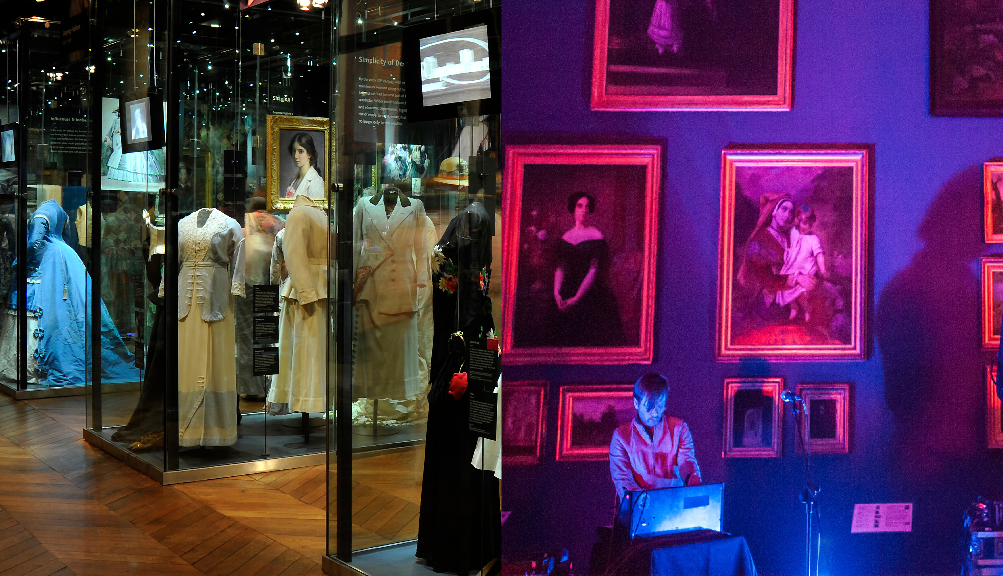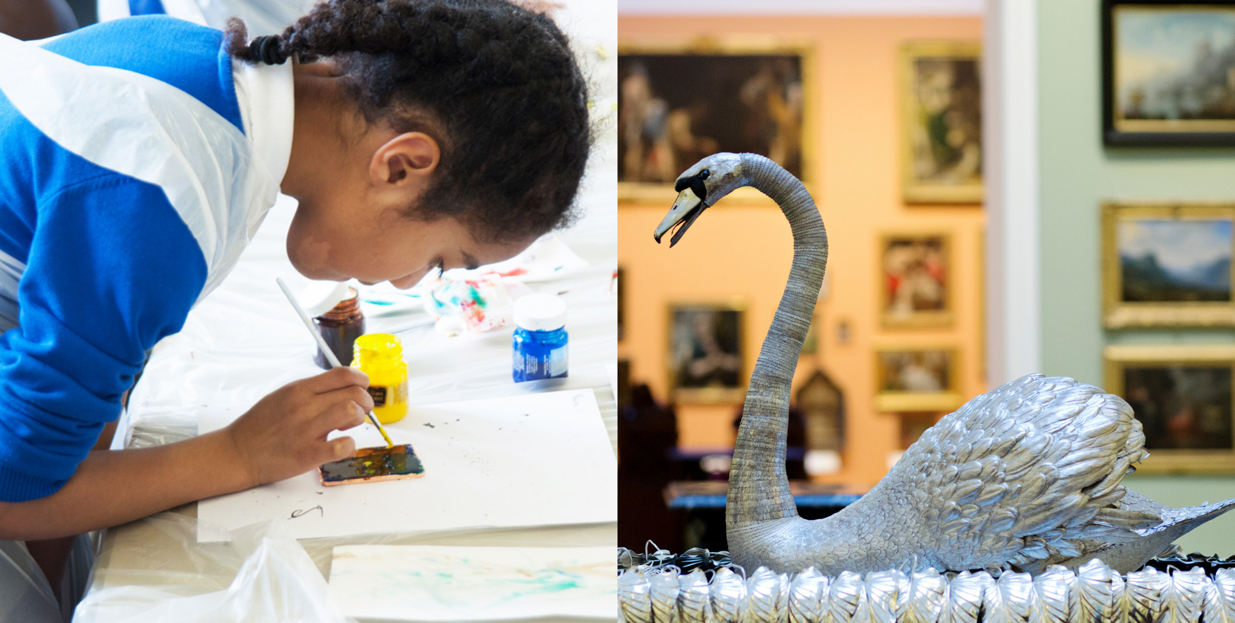

THE BOWES
MUSEUM

APPOINTMENT: PRODUCER (YOUNG PEOPLE & ADULTS)

A future-thinking museum of artists, designers, and makers, created
to support and uplift people and places.
The story of The Bowes Museum is like no other: uniquely, the idea of a woman, Joséphine Bowes, an artist and patron of the arts.
Her determination and passion
for creating a museum were shared by her husband John, who was born in Teesdale.
The Museum stands proudly in the heart of Teesdale, an Area of Outstanding Natural Beauty.
Mission, vision, and values.
Our mission as a future-thinking museum of artists, designers, and makers is to support and uplift the North East through our spirit of generosity and collaboration.

Through this we aim to achieve our vision of unlocking people’s potential to shape a more interesting,
equitable and sustainable world.

Our values underpin our work. We aim to be adaptable, collaborative, creative, experimental, fun, responsible and welcoming.

Collection
We hold the spirit of our founders, Joséphine and John Bowes, within our collections. Joséphine’s interests are reflected in the collection, particularly her love of fine porcelain, fashion, and art. She was a recognised artist who acquired the work of her contemporaries during a vibrant cultural period in 1800s Paris. Our collecting policy, associated programming, and display reflect Joséphine’s interest in the present and the new, celebrating creativity, design, and artisanship.
Visitor Experience
We seek to welcome all, support and celebrate artists, cultivate creative exchange, deliver inspirational learning, and be a place that is used and loved by the people of Teesdale and visitors from further afield.

We aim to put people first by understanding their needs and motivations. We do this by knowing and speaking to our audiences and making our exhibitions and events accessible, inclusive, and relevant. We view our programming ‘in the round’ and want to extend
it beyond our building. Recognising that engagement is digital and physical, we aim to connect with people where they are. We support artists, makers and designers, current and aspiring, through our programmes, exhibitions and partnerships.

Learning is at the heart of The Bowes Museum. We work extensively with children, young people, educators
and older people to raise aspirations and support education for life. Our incredible volunteers are a vital community, working with us in mutually-beneficial ways to support people and places.

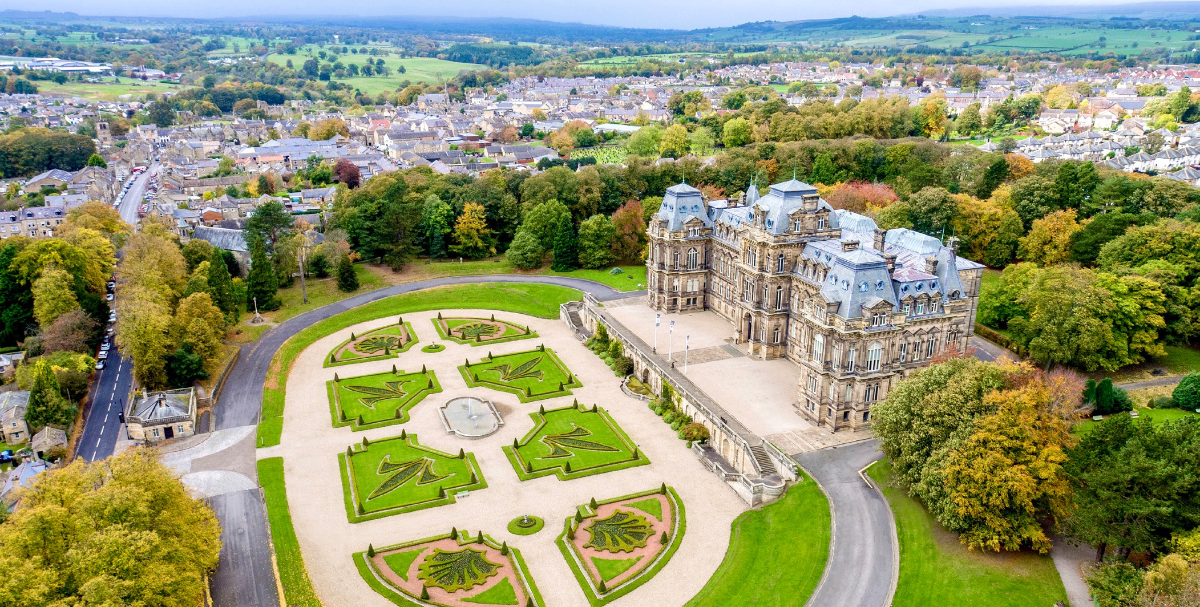
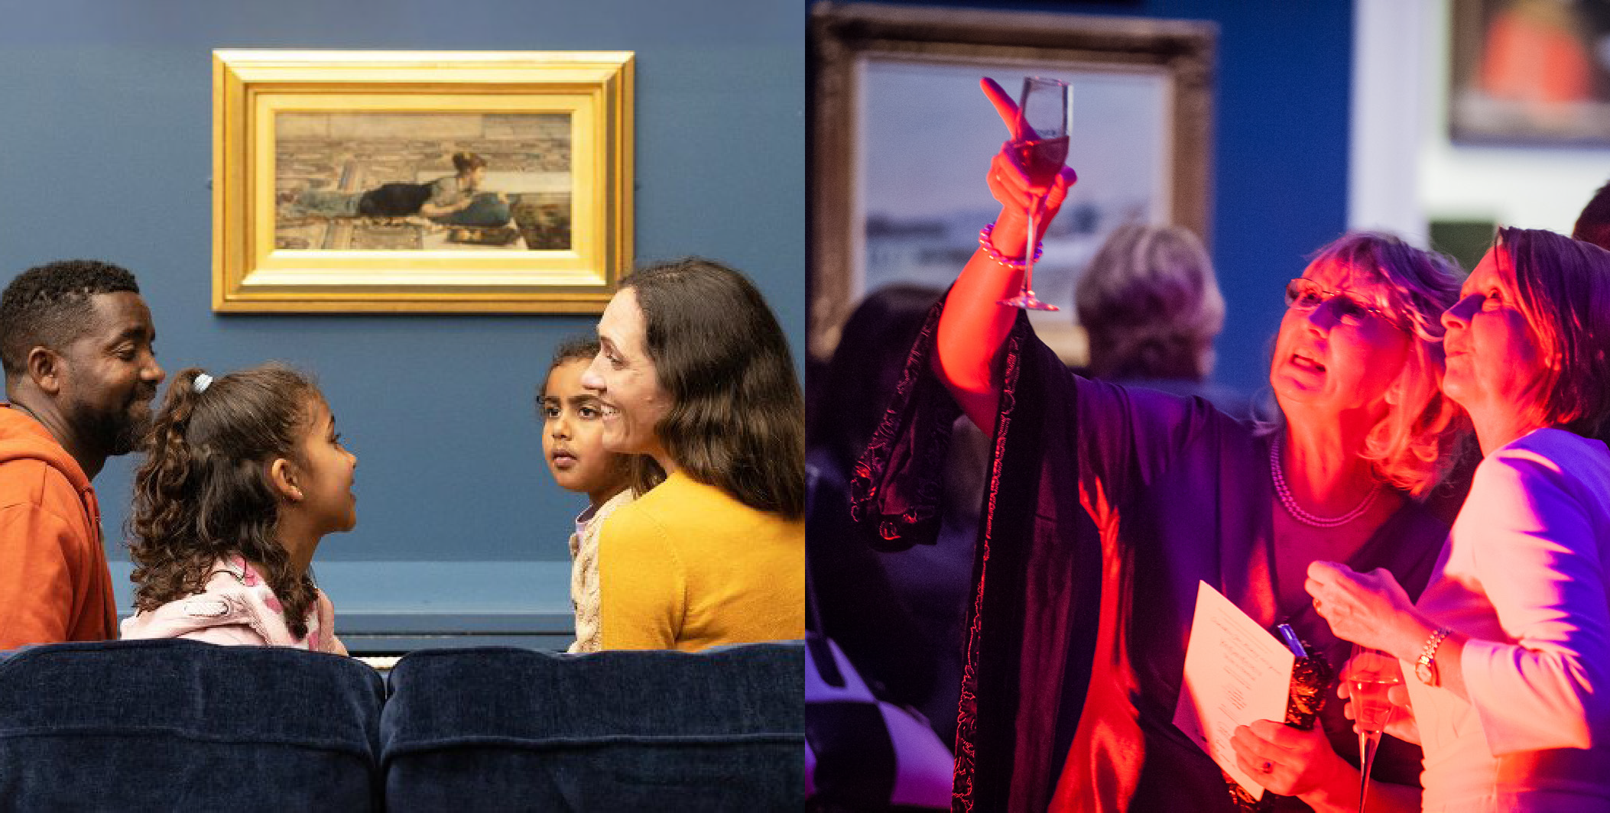
Our grounds are a welcoming space for everyone. We have over 20 acres for local people to call their own. They include a mixture of formal planting and woodland arboretum, with avenues of trees and a terrace, from which visitors can admire the spectacular views of the surrounding countryside. Our shop offers unique pieces inspired by our collections and exhibitions and features local artists and makers. As the Museum feeds the soul, our café feeds the body with its wonderful local and seasonal produce championing producers from Teesdale.

Trading and Operations
Today the Museum employs 80 staff and has a turnover of £3.3m in the charity and £945k in the the Enterprises Trading Company. Our team is responsible for a broad spectrum of work across operations, finances, exhibitions, programmes, commercial activities, marketing and collections. As an Arts Council England (ACE) National Portfolio Organisation (NPO), we are proudly contributing to ACE’s ‘Let’s Create’ mission.
Our audiences’ needs, voices and responses are vital to our success. We aim to ensure our audiences recognise and celebrate the Museum
and its collections as vital to them. There are many parallels between the time of our founders and issues affecting society today.

THE BOWES
MUSEUM

APPOINTMENT: PRODUCER (YOUNG PEOPLE & ADULTS)

The Opportunity
We are seeking candidates for the position of :
Producer
(Young People & Adults)
Part Time.
30 hours per week
Monday - Thursday
(including some weekends
and evenings)

This role offers an exciting opportunity to develop and deliver engaging learning programmes, events and projects that connect young people and adults with the Museum’s collections, building and parkland.
The opportunity includes
The Producer (Young People & Adults) will work within the Learning team, closely alongside the Producer (Education & Families).
This role involves creating and delivering activities, events and projects for young people and adults at The Bowes Museum. The role focuses on helping people connect with the Museum’s collections, building and parkland through creative and engaging experiences. It includes working with community groups and partner organisations, developing relationships, co-producing programmes, and commissioning and working with artists, designers and makers.
The post holder will plan projects, manage budgets and practical arrangements, promote activities, evaluate their impact and ensure programmes are inclusive, safe and accessible.

The Person
We are looking for a creative, enthusiastic and proactive person who is passionate about engaging young people and adults through culture, art and heritage. You will have strong communication and relationship-building skills, with experience of working with communities, developing engaging activities and working collaboratively with artists, designers, makers and partners.

To be successful in the role you will be able to prioritise and balance a busy workload and be confident in bringing ideas to life, supporting co-produced projects and creating welcoming, inclusive experiences for a wide range of people.
You should be organised and adaptable alongside committed to making the Museum’s collections and spaces accessible, relevant and inspiring for all.

THE BOWES
MUSEUM
APPOINTMENT: PRODUCER (YOUNG PEOPLE & ADULTS)

Specific Responsibilities:
- To lead on the initiation, development and delivery of learning initiatives relevant to targeted communities of young people and adults in line with the direction of The Bowes Museum.
- In collaboration with the Experiences & Learning Manager and wider programming team, lead on the development and delivery of a highly engaging young people and adult learning programme that builds connection, curiosity and creativity with a variety of local communities and stakeholders
- Build relationships and partnerships with regional, national and international individuals and organisations to develop and deliver joint projects.
- Regularly evaluate and report the outcomes and impact of community young people and adult programming at The Bowes Museum keeping necessary records and processes in place to inform these reports.
- Work in partnership on and off site with groups and organisations as required.
- Ensure that relevant activities are delivered professionally and in a timely manner to maximise meaningful engagement; including health and safety, budget management, programme plans, communications plans, agreements, and evaluation activities.
- Contribute effectively to the success and culture of The Bowes Museum.
- Interact and cooperate proactively with all employees, trustees and volunteers, ensuring good teamwork, inclusive practices, and interdisciplinary activities across work strands, projects and programmes.
- Manage individual performance of assigned staff, volunteers, and researchers as appropriate and in line with the organisation’s performance management processes.
- Develop reports, with the support of the Experiences & Learning Manager for Senior Leadership Team, Exec Director, Trustees, Committees, Funders etc.
- Make best use of technology across our activities and support effective communications and promotion of The Bowes Museum and our activities.
- Work flexibly at times and on occasions that connect with the needs of our audiences and communities.
- Ensure we are adhering to and compliant with our policies, processes and statutory obligations.
- Take ownership of your professional and personal development, working with your line manager to identify and address gaps in skills and competencies.
- Ensure that the Health and Safety and Safeguarding policies, organisation arrangements and procedures under your control are understood, implemented, and monitored.
- Help to ensure any barriers to equality of opportunity are removed and to eliminate unfair and unlawful discrimination, giving everyone an equal chance to learn, work and live free from discrimination and prejudice.
- Demonstrate and advocate for the museum’s values and behaviours in all we do.

See separate Role Description and Person Specification for full requirements.

THE BOWES
MUSEUM

APPOINTMENT: PRODUCER (YOUNG PEOPLE & ADULTS)

Terms of appointment
This role is based at The Bowes Museum, Barnard Castle, Co. Durham.
Hours: This role is 30 hours per week (4 days)
Term: Part Time
Salary: £22,364.92 (Actual)
25 days holidays, plus Bank Holidays (FTE).
- 5% employers pension contribution.
- Discount in the museum’s café and our shop.
- Free staff parking.
- Employee Assistance Programme.
- Cycle to work scheme
- Training and development opportunities.

How to apply
The closing date for applications is 8am, Friday 18th September 2026
We anticipate interviews will take place week commencing 21st September.
To apply please follow this link: https://talent.sage.hr/jobs/5d711029-a52f-4cdd-af93-1b7538db42d0

We want to hear how you think you are the right person for the role, and why you think we’re the right place for you. To give yourself the best opportunity, consider how you fit the Person Specification we’ve outlined in the Recruitment Pack and share your response to
this in a covering letter, supported by your CV.

To download the full Person Specification visit https://thebowesmuseum.org.uk/jobs-and-volunteering
We believe that diversity and equality within our workforce, programmes and approaches are crucial to our mission of being inclusive and relevant to our communities. We want everyone to feel welcome. We, therefore, particularly welcome applications from candidates under-represented at The Bowes Museum and within the heritage sector, including Global Majority candidates and/or candidates with disabilities

THE BOWES
MUSEUM

We can’t wait to hear from you.

